Iteration 6
26/03/2021

Introduction
This being the final iteration it was important that not only did I achieve my goals from the last iteration but also that I deliver a polished fully functioning application ready for purpose.
In saying this I needed to take a last look back at my user stories and product backlog list.
Over this past iteration I learnt how valuable my user’s data was and how much extra functionality I could give just by accessing the user type.

Walkthrough of Each Activity and Fragment
Login Activity
Th first activity met is the login.
- An email address can be typed into email edit text with a password in the password edit.
- The edit texts have input types on them making it easier for users.
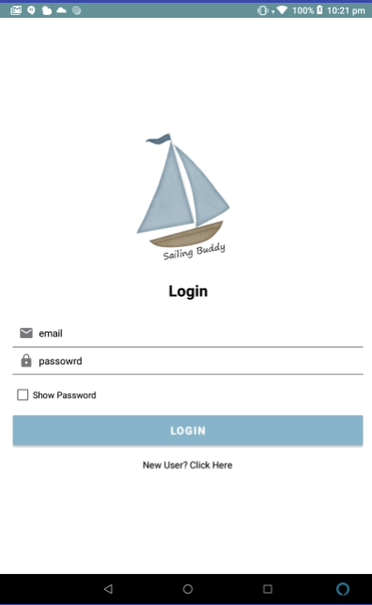
- When show password is clicked the masked view reveals the password being typed in?
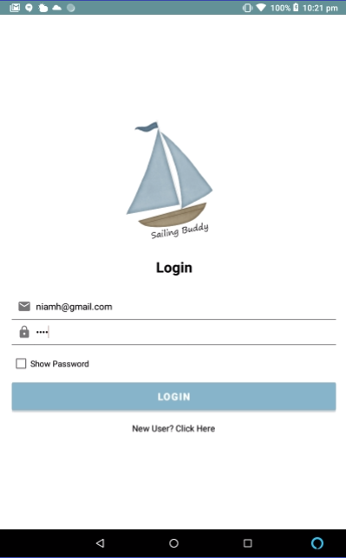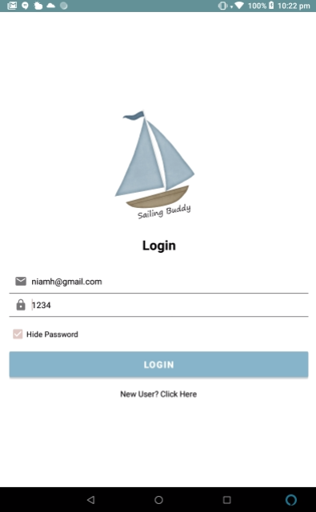
- The Login Button bring you to the dashboard and sets a shared preference that keeps you logged in even if the app is closed.
- The new Register enter here button brings us to the Register Activity.
Register Activity
- Register activity used to add new users to users’ table.
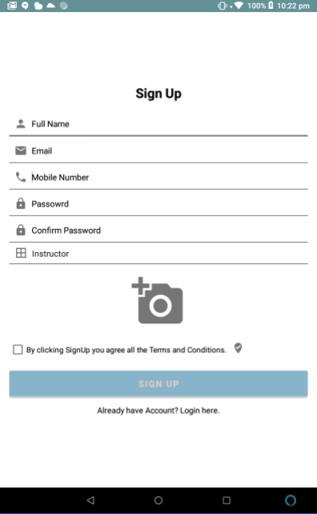

- Each input has a specific view type like number email password for user’s ease.
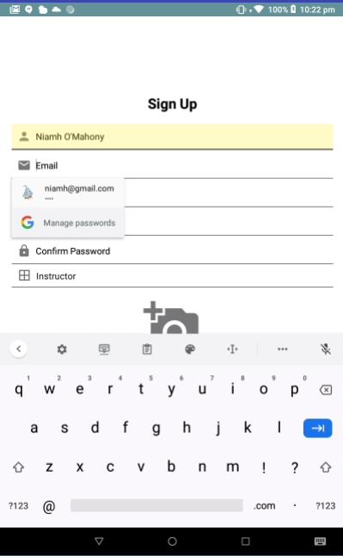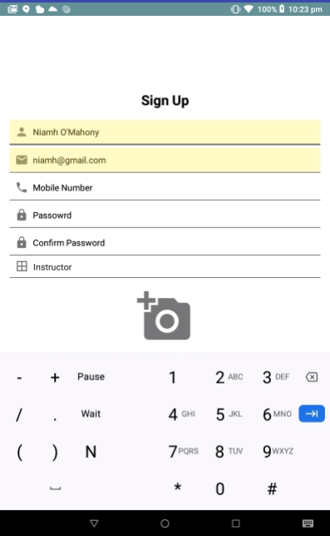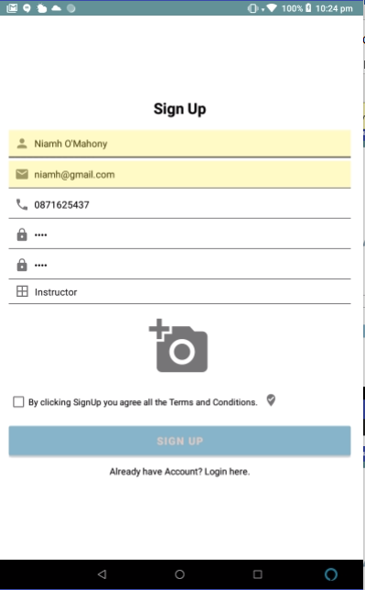
- Admin/Instructor spinner is password protected so that user cannot just decide to be an admin.
- If password is entered correctly spinner will show either admin or instructor otherwise it will not let you have admin as an input

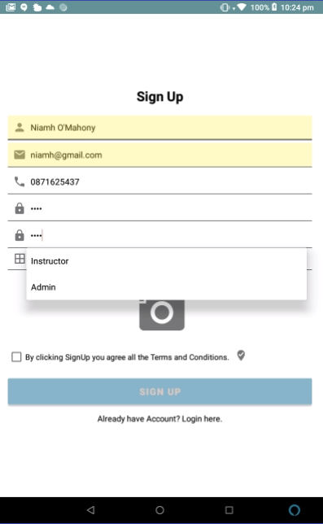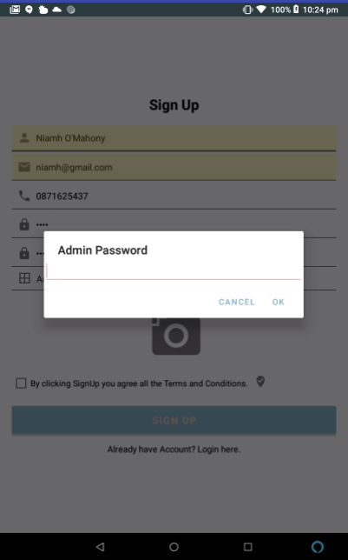
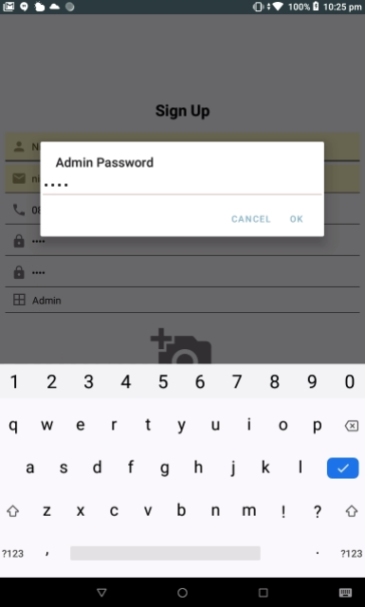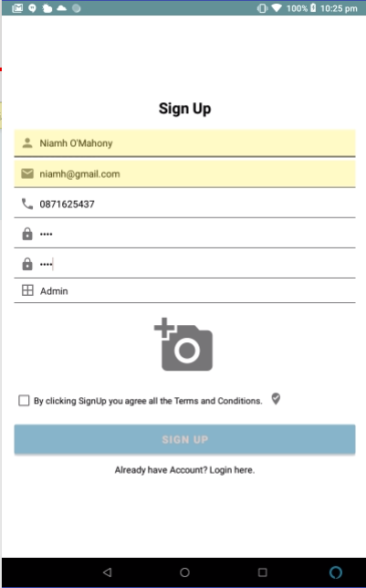
- Adding image users in with popup dialog that allows you access gallery or camera.
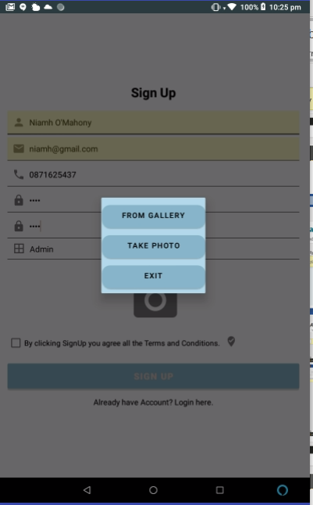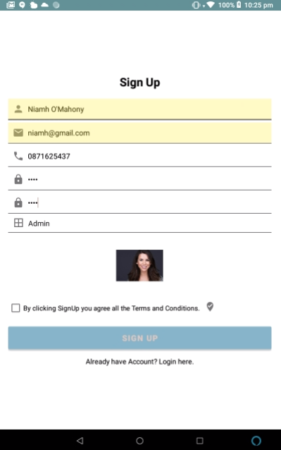

- Popup toasts appear error handling if user has not entered all details if the passwords are incorrect or if the user hasn’t confirmed the terms and conditions.
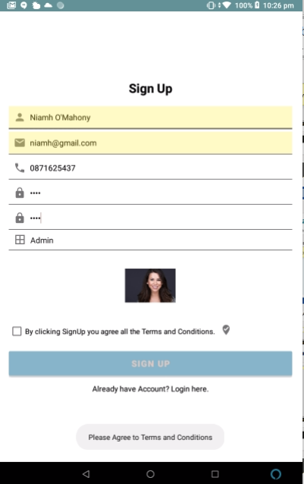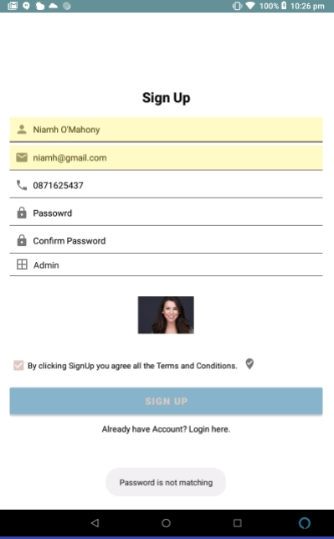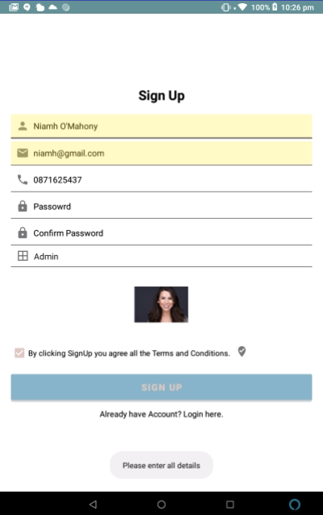
- When tick drop icon is selected terms and conditions dialog pops up that user can rad and close before accepting
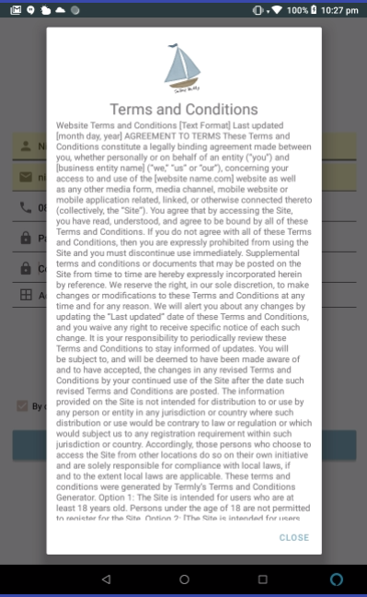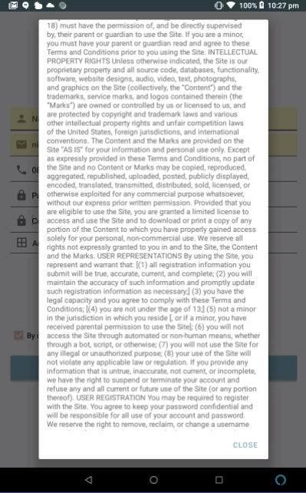

Dashboard Activity
- Dashboard activity gets logged in users name and picture put on display.
- Also gets local weather forecast to activity.
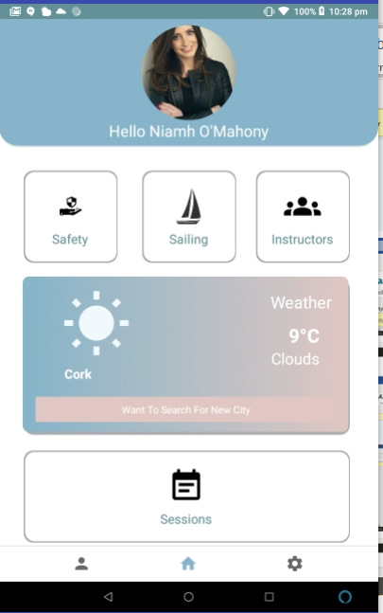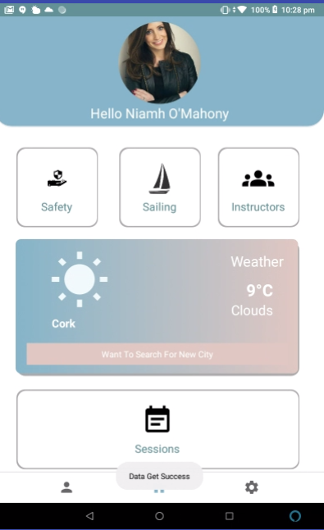
Profile Activity
- Displays all the logged in users Details.
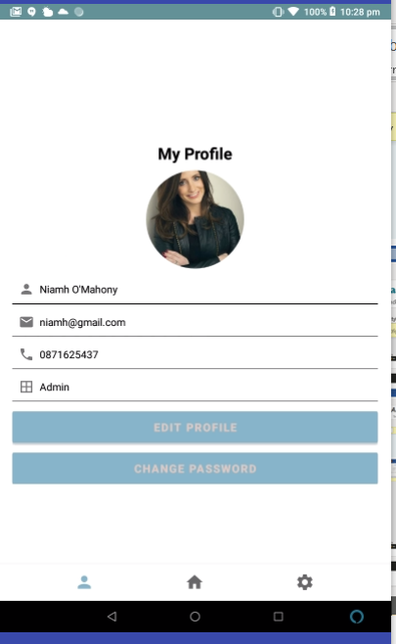

Profile Edit Activity
- Edit all logged in users details except for password.
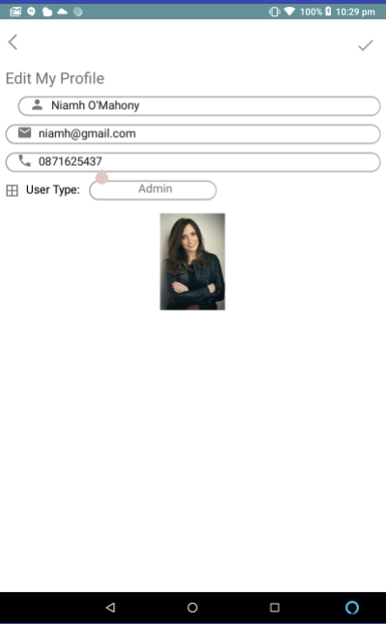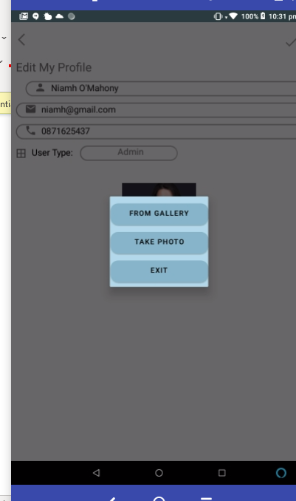

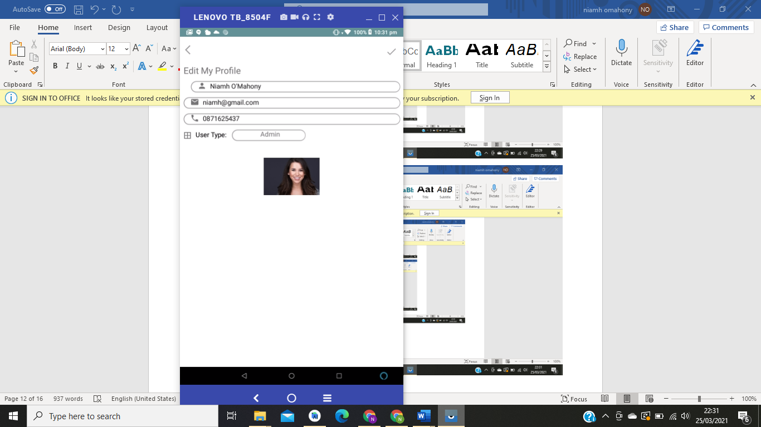

Password Edit Activity
- Separate activity for password changing.
- Also, password protected with phone number digits.
- When changed user signed out to login activity?
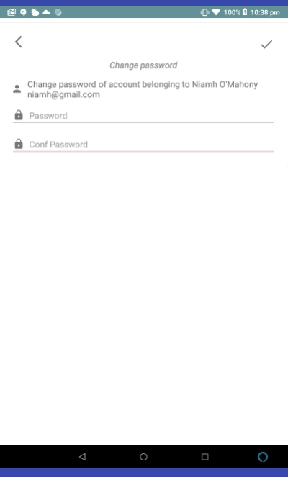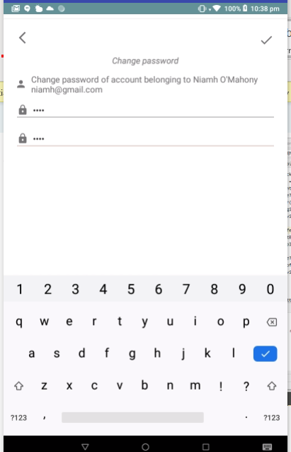
- If correct you get logged out if incorrect you get sent back to profile activity

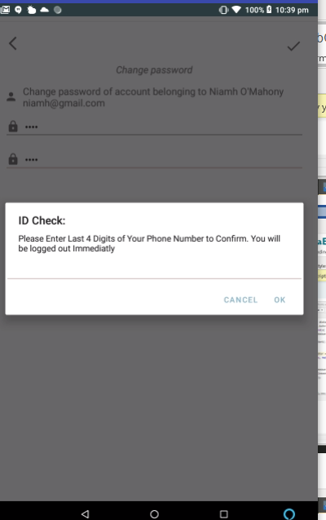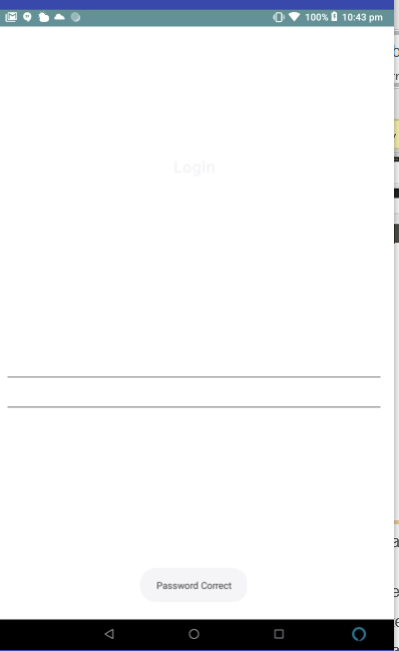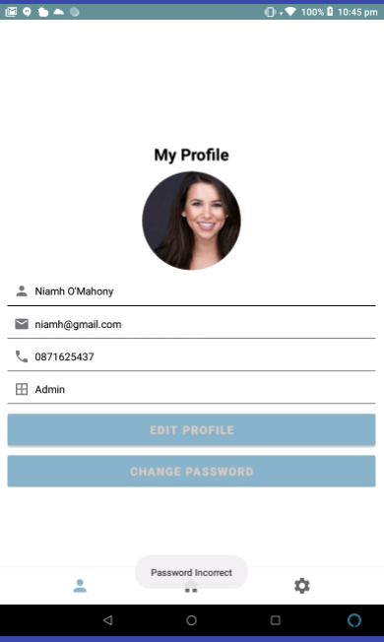

Settings Activity
- Loout brings you back to login activity and you no longer stay logged in.

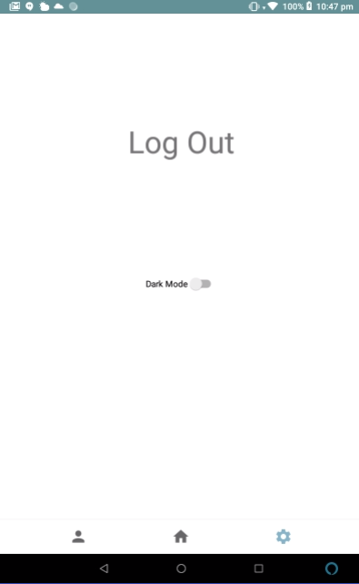
Safety List Activity

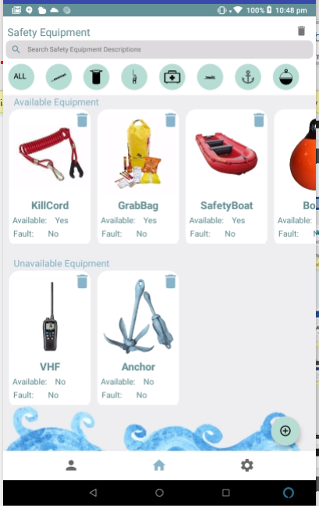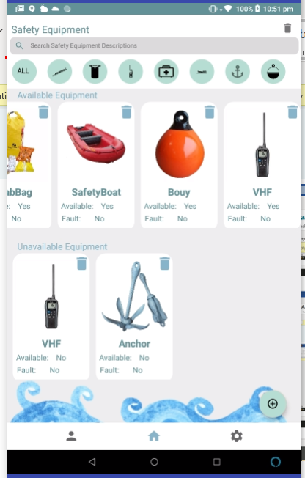
Create Safety Fragment

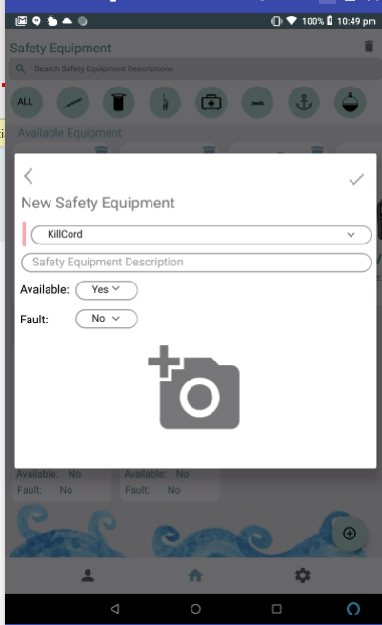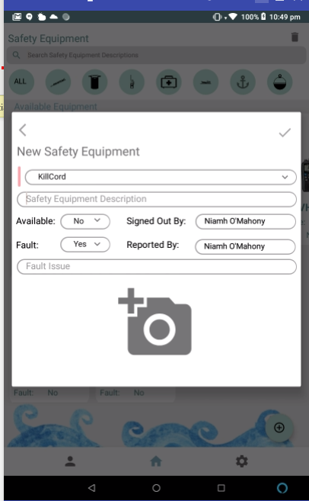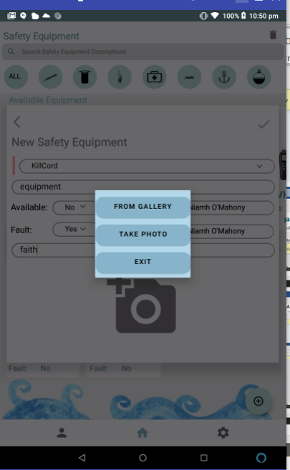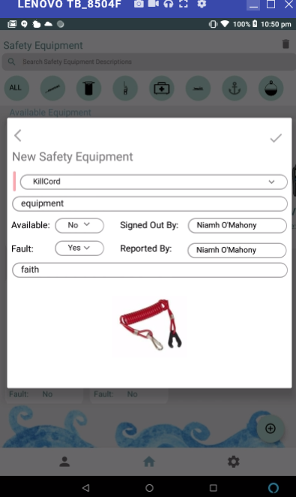

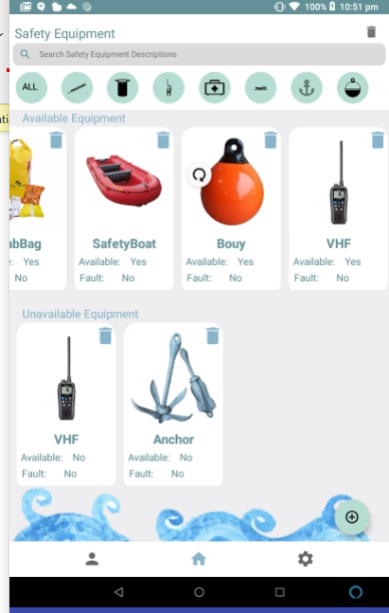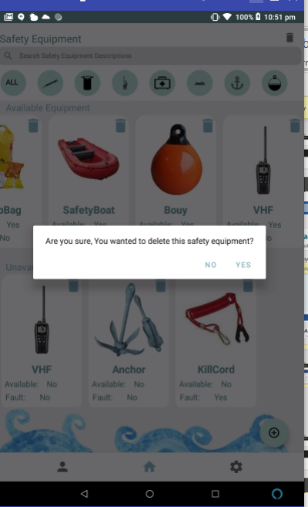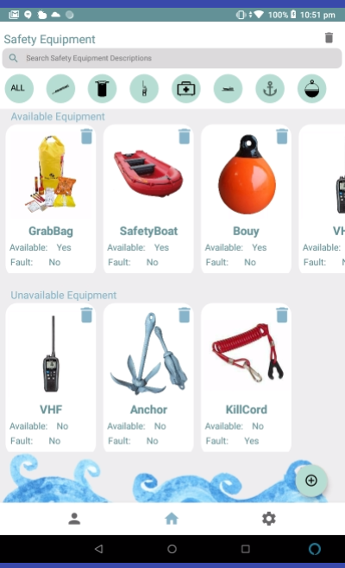

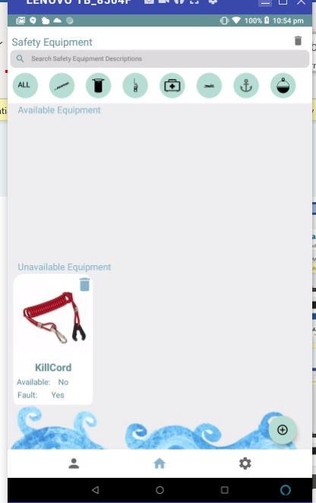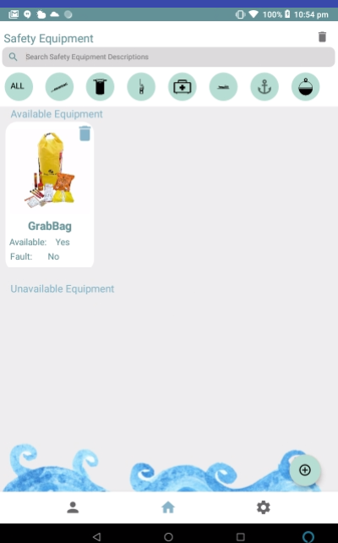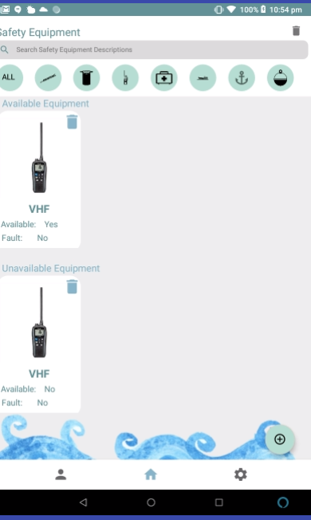
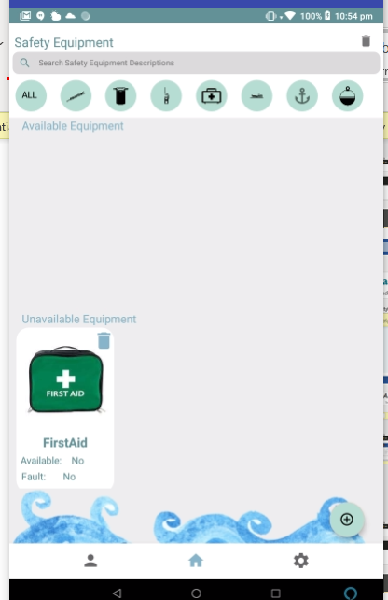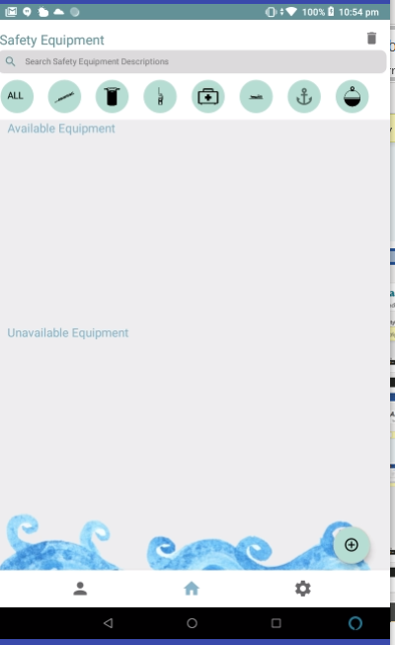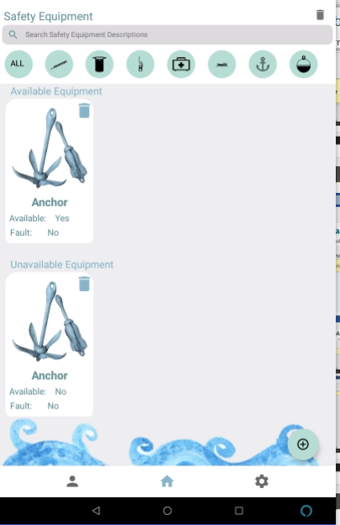
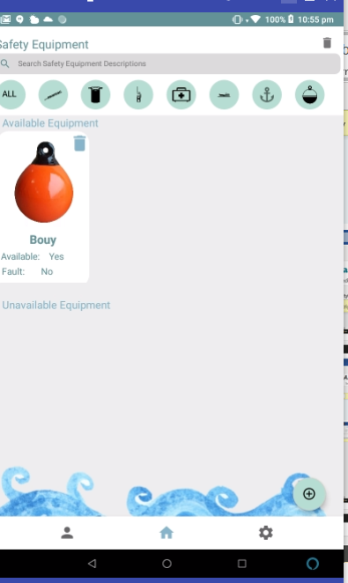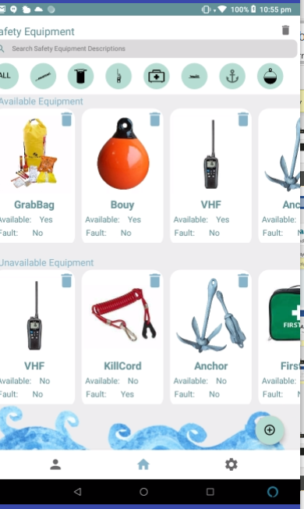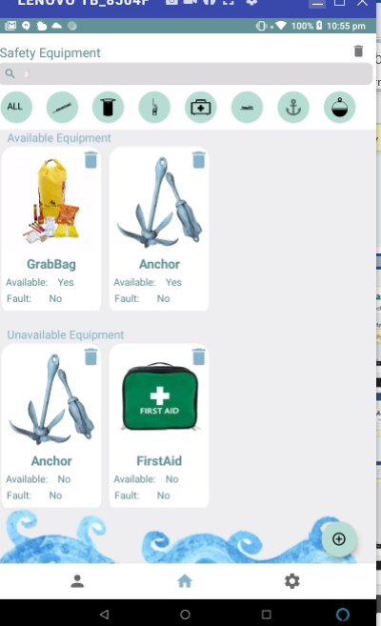

Sailing List Activity
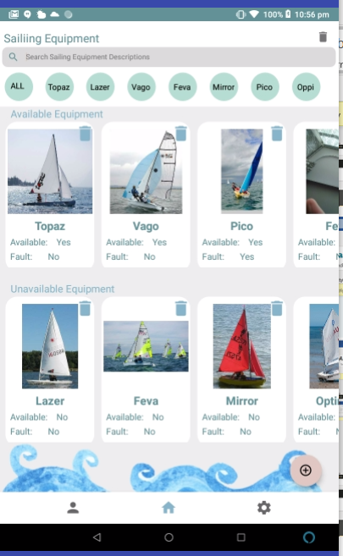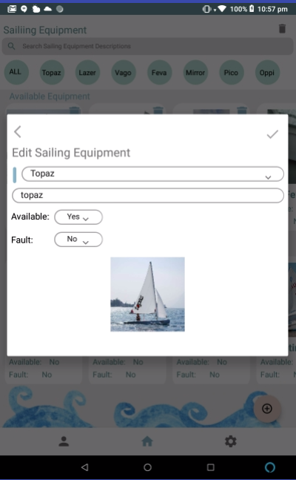

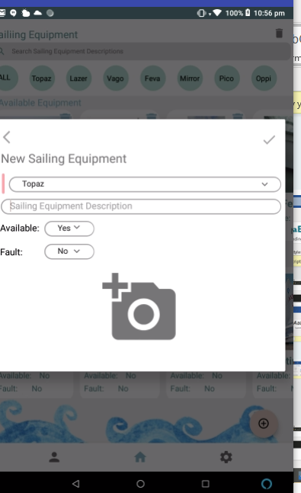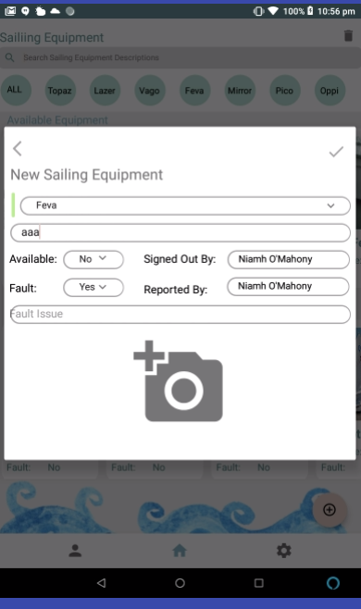
Update Safety Fragment

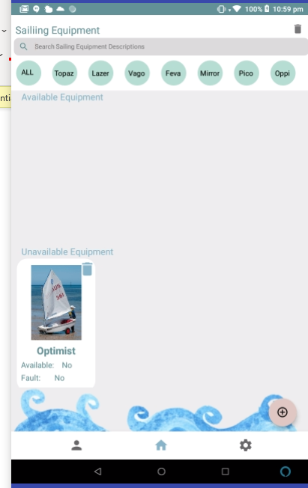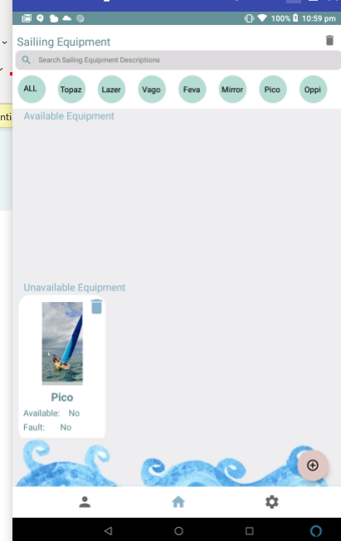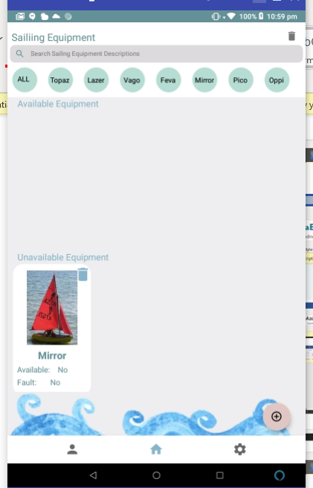
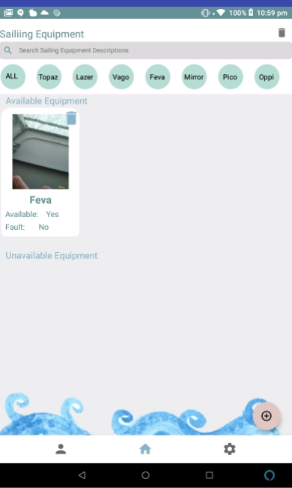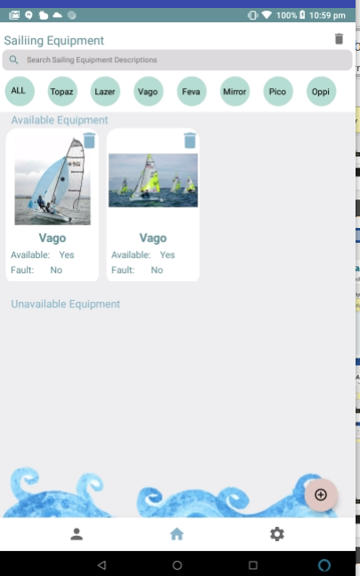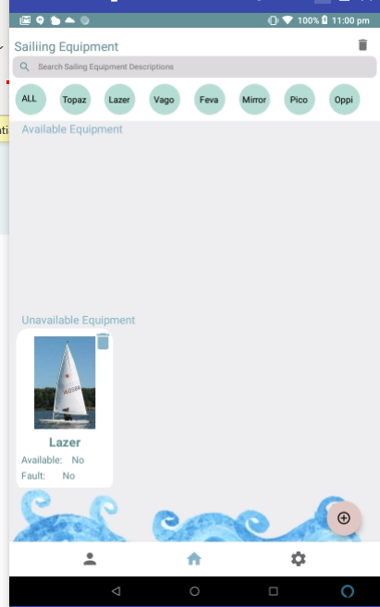
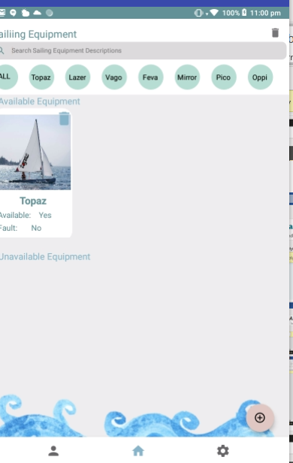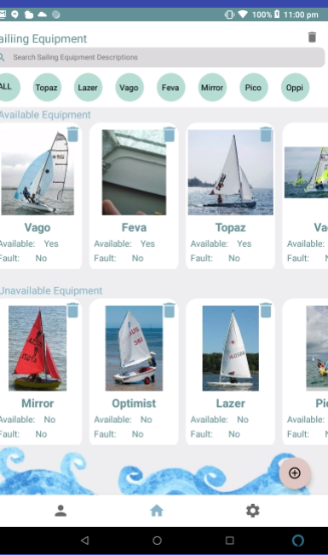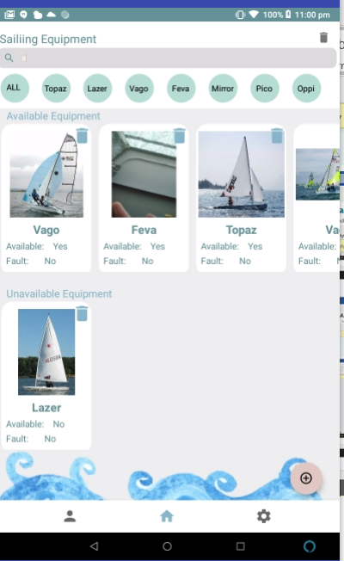

User List Activity
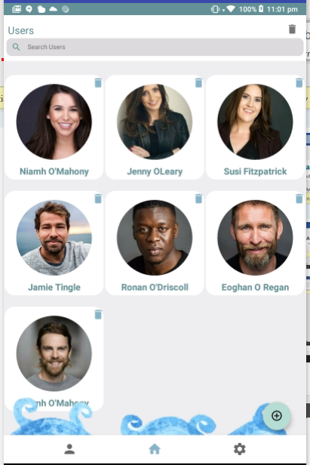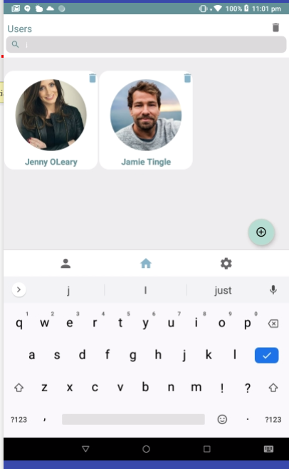

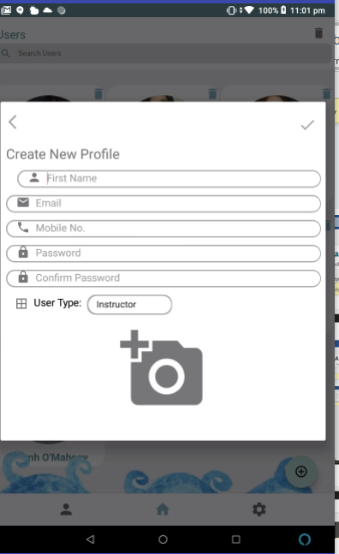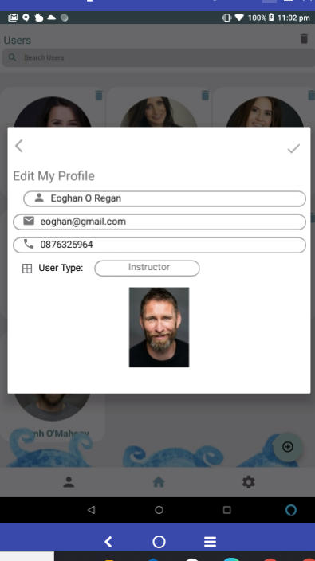
Session List Activity

- Admin can see all the user’s session plans sorted by date and most recent shown first.
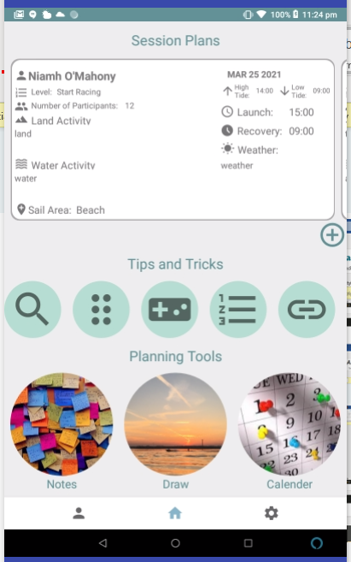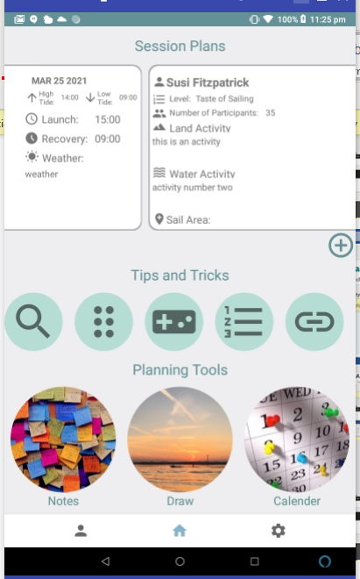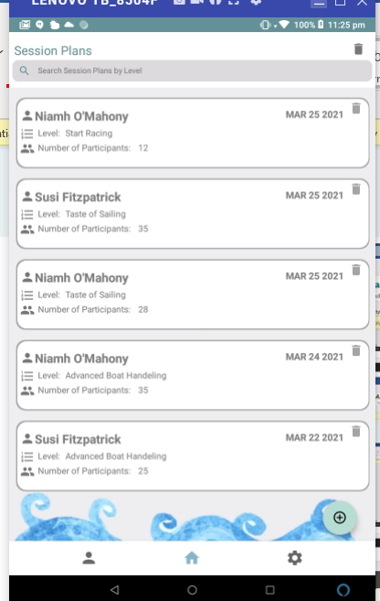
- Create auto inputs instructor name and today’s date to change the date just click the text view and the dialog box appears same for the times.
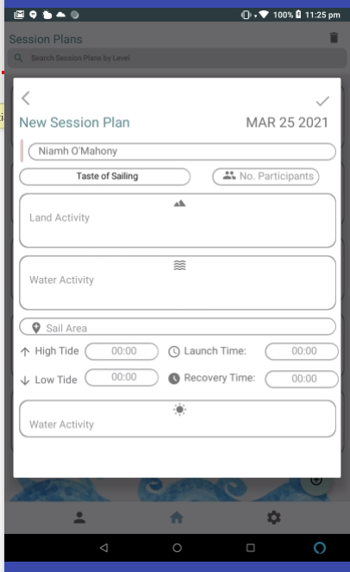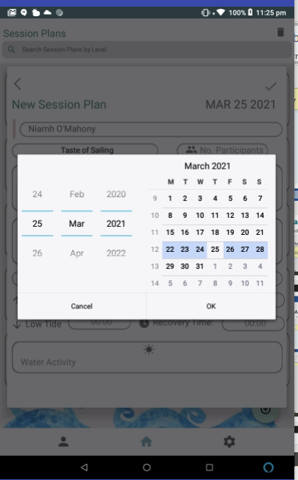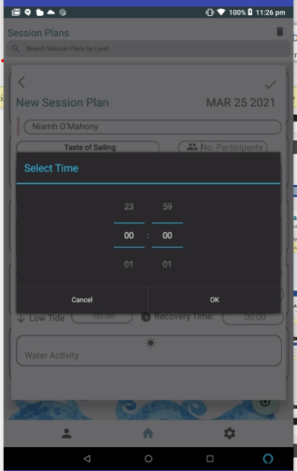

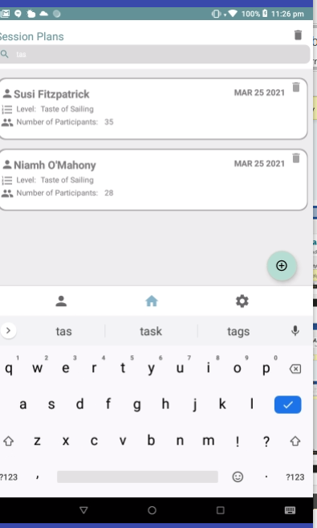

Paint Activity
- Used for instructors to explain points and expand theories.
- Colors change when each pen is clicked.
- Eraser is a black pen.
- Clear removes all
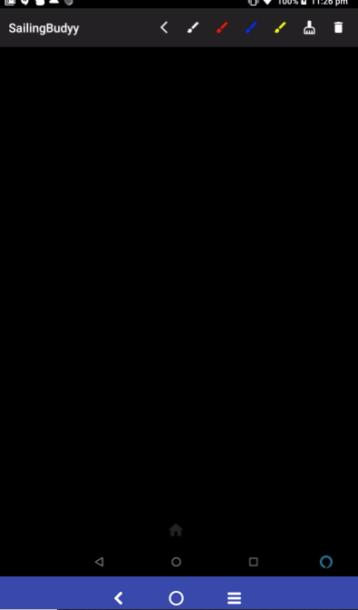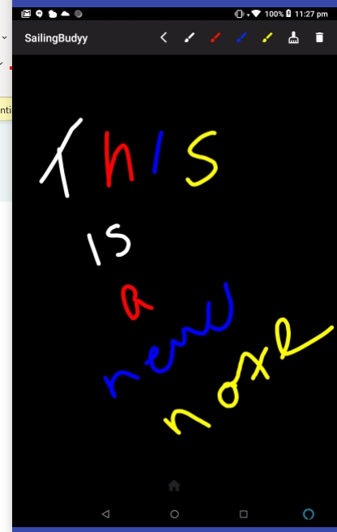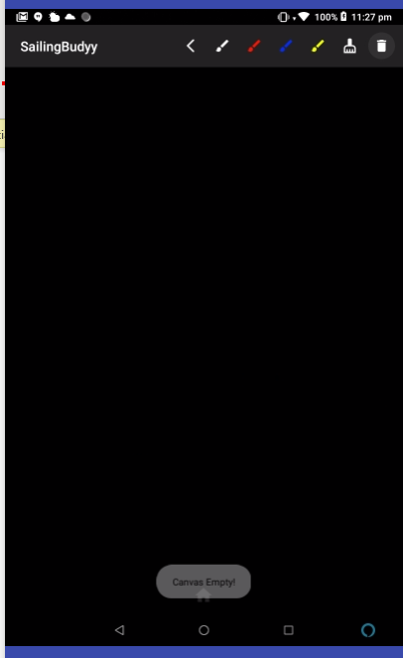
Notes in Session Activity
- Basic notes application with CRUD like other recycler views

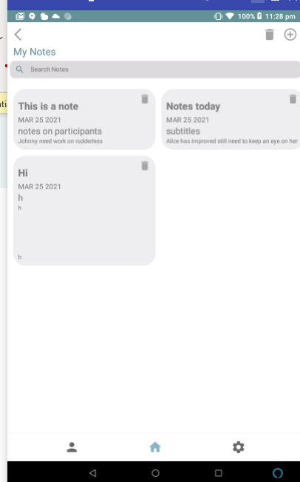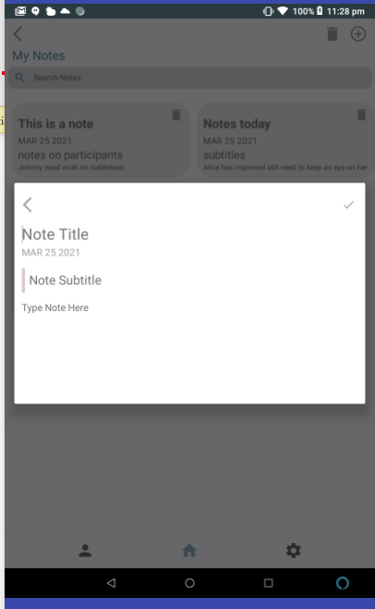
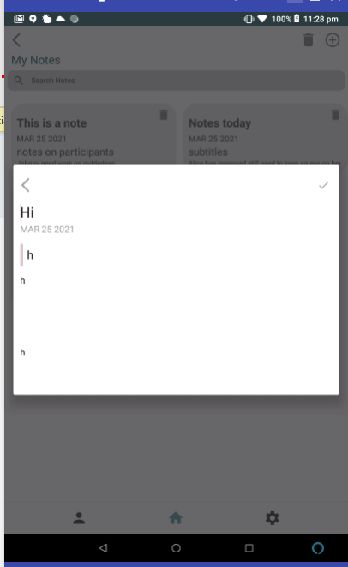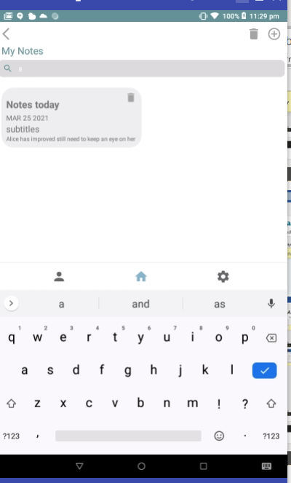
Calendar Activity
- Shows basic calendar recycler view with Monday always lining u correctly.

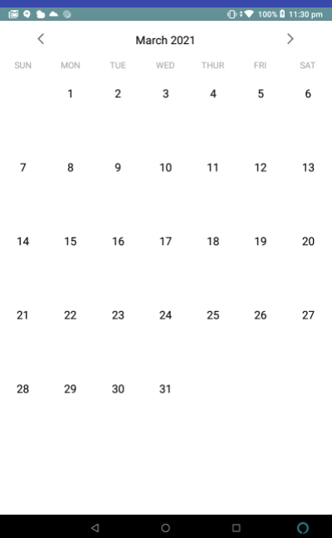

Dashboard Activity for Instructors
- All identical capabilities to admin dashboard but links to different views based on user type.
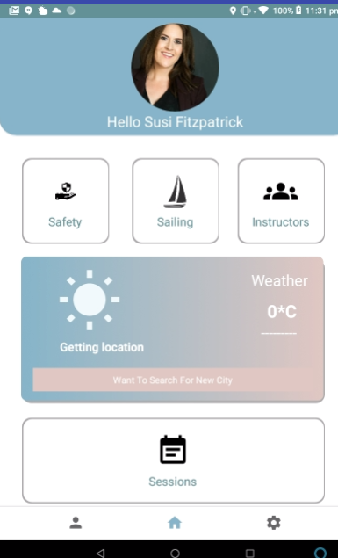
Safety List Activity for Instructors
- View All safety equipment filer and search like admin but only edit 3 attributes as everything else is hard coded in

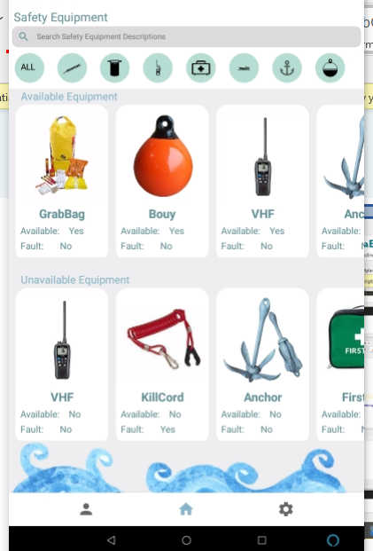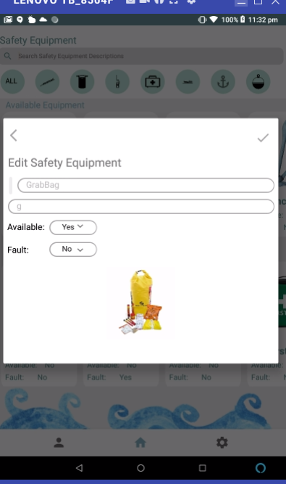

Sailing List Activity for Instructors
- View All safety equipment filer and search like admin but only edit 3 attributes as everything else is hard coded in

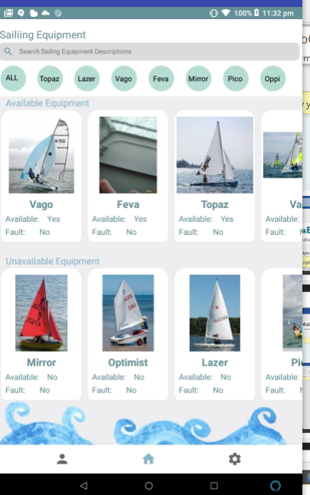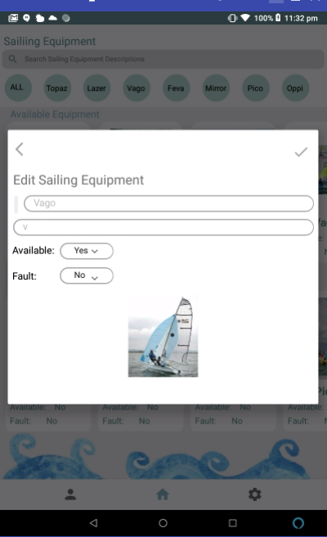

User List Activity for Instructors
- Instructors can view other instructors.
- Instructors can view other instructors.
- Search functionality

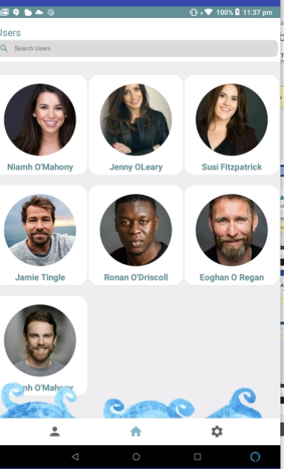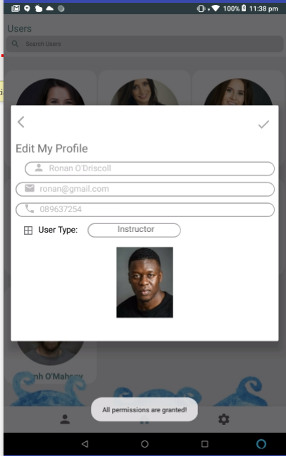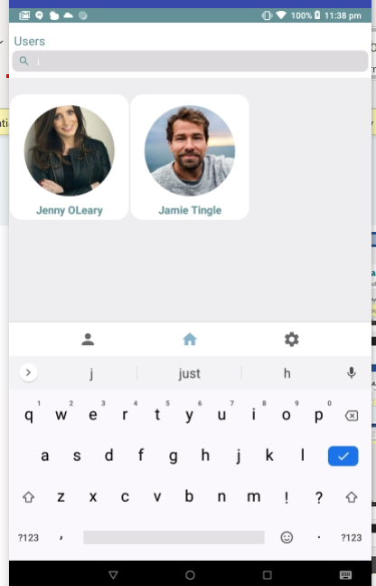
Session List Activity for Instructors
- Instructor can only view and search their own sessions in both views.
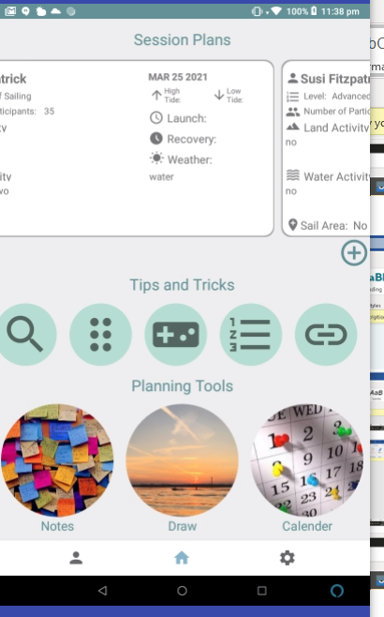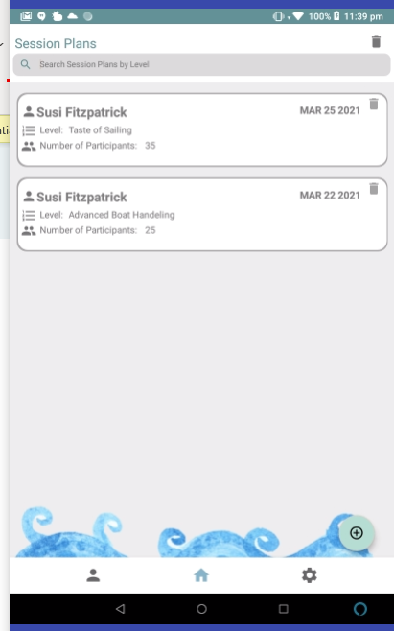

User Stories
Completed User Stores
Safety equip.
- As an Instructor I want to view available and unavailable safety equipment So that I can choose what equipment is available for me to use in my session
- As an Instructor I want to sign in/out safety equipment So that there is a record of who has what
- As Senior Instructor I want to view available and unavailable safety equipment So that I can see who is using which equipment.
- As an Instructor I want to have the option to update the status of safety equipment So that I can indicate if its broken or missing and give a description of the issue
- As Senior Instructor I want to have the option to update the status of safety equipment.
So that I can indicate when equipment is repaired or replaced and ready for use
- As Senior Instructor I want to be able to add or remove safety equipment So that I can control what equipment is available to instructors.
Sailing equip.
- As an Instructor I want to view available and unavailable sailing equipment So that I can choose what equipment is available for me to use in my session
- As an Instructor I want to sign in/out sailing equipment So that there is a record of who has what
- As Senior Instructor I want to view available and unavailable sailing equipment So that I can see who is using which equipment.
- As an Instructor I want to have the option to update the status of sailing equipment So that I can indicate if its broken or missing and give a description of the issue
- As Senior Instructor I want to have the option to update the status of sailing equipment So that I can indicate when equipment is repaired or replaced and ready for use.
- As Senior Instructor I want to be able to add or remove sailing equipment So that I can control what equipment is available to instructors.
Session Activity
- As an Instructor I want to be able to input my daily session plan So that I can have a clear plan for the day that my senior instructor can also see this
- As an Instructor I want to edit my session plan So that if there is a significant issue, I can change the daily plan to suit.
- As an Instructor I want to view my previous session plan So that I can see what I have already done, what needs extra work and give a varied curriculum.
- As an Instructor I want to view the curriculum for each level So that I can incorporate these skills into my plan and ensure I am not forgetting any.
- As an Instructor I want to be able to see some tips and tricks for sessions So that I can use new games, exercises and instructing methods.
- As Senior Instructor I want to view all instructor’s daily session plans So that I can have a clear idea of what each group is doing and where.
- As an Instructor I want to be able to input my ideas into the tips and tricks section So that I can impart my knowledge for others to use
- As senior Instructor I want to edit the curriculum and tips and tricks So that I can control the environment if there are any changes.
Dashboard
- As an Instructor I want to view a dashboard of each components So that I can easily access each section
- As a Senior Instructor I want to view a dashboard of each components So that I can easily access each section
My Profile
- As an Instructor I want to have a profile So that I can have my personal information up to date and make available to my senior instructor
- As Senior Instructor I want to have a profile So that I can have my personal information up to date in the one place.
- As Senior Instructor I want to view each instructor’s profile So that I can contact them easily and see any medical conditions for emergencies.
- As an Instructor I want to add, edit, delete instructors So that I can have up to date information of who is working.
Weather
- As an Instructor I want to see the daily weather So that I can plan my sessions around it to keep my group safe
- As Senior Instructor I want to see daily weather So that I can plan the course and help instructors change their plans if necessary, to keep everyone safe.
Login
- As an Instructor I want to log onto the app So that I can see my own personalized dashboard
- As a Senior Instructor I want to log on to the app So that I can see my own personal dashboard differing to instructors

What Next
As this is the final iteration there is no future but there is a what if
This was such a valuable experience I can draw on and learn from
In every project there is things you wish you did differently
E.g., I might have chosen a MySQL database to show functionality better.

